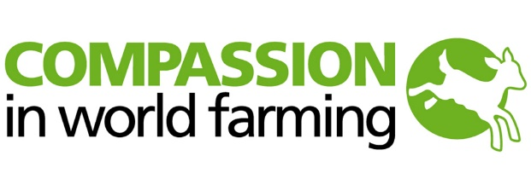

Head of Compassion in World Farming UK

Salary Up to £65,000 depending on experience

Permanent – Full Time

Godalming HQ – Hybrid – with up to 3 days per week working from home

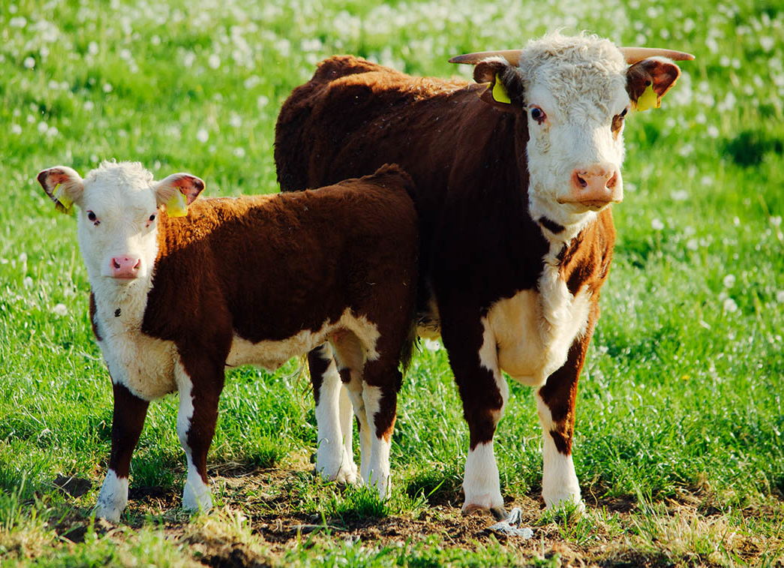

Welcome
Dear Candidate,
I am delighted at your interest in joining Compassion in World Farming International.
This is an immensely exciting time for our issue, our organisation, and our movement. We are seeing unprecedented opportunities to make game-changing progress for animal welfare and moving toward a world without factory farming. Just one example is the recent announcement by the European Commission that it will legislate to end all cages for animals farmed for food – due in no small part to our End the Cage Age campaign.
At the same time, there is growing recognition of the need to transform food systems and reduce meat consumption if we are to stave off climate, nature, and health emergencies worldwide. There has never been a better time to press for animals to be treated with compassion and respect, and to show that humane and regenerative food lies at the heart of solving some of the biggest challenges facing humanity.
Our current strategy focuses on mobilising a movement and delivering key legislative reforms for animals. We have our sights firmly set on achieving progress globally, not least through a UN global agreement to transform food systems away from industrial agriculture and meat-heavy diets.
Please take the time to read this pack and to find out more about Compassion at www.ciwf.org. This is an outstanding opportunity for someone who connects with our values and wants to make a lasting impact for animals, people, and the planet. I do hope that you are inspired to be part of our journey and we look forward to receiving your application.
With best wishes
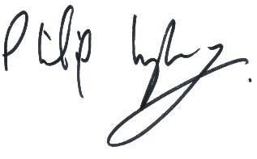
Philip Lymbery
Chief Executive Officer

About Compassion
Compassion in World Farming International is a registered charity that works globally to end all factory farming practices. We believe that the biggest cause of cruelty on the planet deserves a focused, specialised approach – so we are relentlessly focused on ending factory farming.

Cruelty to animals is wrecking the planet.
FARM ANIMALS ARE SUFFERING  Over the last half century, the industrialisation of the countryside has led to farm animals disappearing from the land to be caged, crammed and confined in factory farms. This has had a devastating impact on animal welfare. |  |  |  |  | 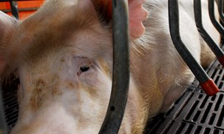

OUR WILDLIFE IS DISAPPEARING
About two-thirds of wildlife loss is driven by food production, with industrial agriculture – factory farming – the most damaging.
OUR ENVIRONMENT IS UNDER SERIOUS THREAT  With nearly half the world’s usable land surface devoted to agriculture, the way we feed ourselves is now a dominant activity on the planet, affecting farm animal welfare as well as wildlife and the natural ecosystems on with human society depends. |  |  |  |  | 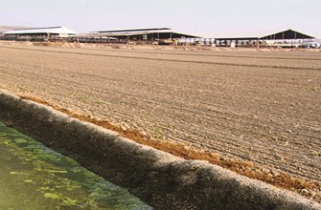

MEANWHILE, WE ARE WASTING FOOD
More than a third of the world’s cereals (and most of its soya) is fed to farm animals, wasting more than two-thirds of the calories and protein in conversion to meat, milk, and eggs. This highlights the sheer inefficiency of feeding crops to farm animals that could be feeding people; or, more properly, from croplands that should be growing food directly for people.

Our solutions
There is a growing need to diversify the range of protein sources for people, reducing the overall amount of meat consumed. This would promote healthier diets, reduce greenhouse gas emissions, help restore the natural environment, make it easier to feed a growing world population and provide greater scope for the very best animal welfare.

A world better fed without factory farming
HAPPIER, HEALTHIER FARM ANIMALS  If we get rid of cruel factory farms and restore farm animals to the land in mixed rotational farms, there are huge benefits to be had. Free-ranging animals can express their natural behaviours – running, flapping, grazing – making for happier animals with better immunity, cutting down on the need for veterinary antibiotics and reducing the risk of disease. |  |  |  | 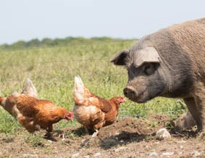
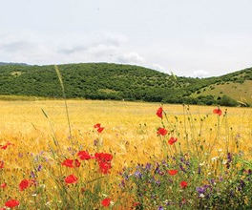 |  | BREATHE LIFE INTO OUR LANDSCAPES  By returning to rotational farms and naturally reared animals, we can bring a cascade of positive benefits for the environment too. When free range animals can wander fields and pasture, they help to regenerate soils. They re-engage the age-old nitrogen cycle where sunlight pushes up plants, eaten by animals whose droppings return nourishment to the soil.

DELIVER ABUNDANT FOOD
If we cut by half the amount of cereals and soya fed to farm animals, it would free up enough food for an extra 2 billion people. This would swell the world’s food basket to feed the 9 billion people anticipated by 2050 without the need for a hectare more farmland.

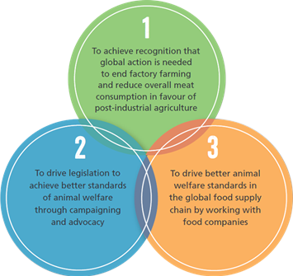
Our strategy

OUR PLAN IS TO BUILD ON

THREE CHANGE GOALS:

WE WILL:
- Show that ending factory farming is key to humane and sustainable food.
- Push for a global agreement to end factory farming in favour of post-industrial agriculture.
- Convince intergovernmental agencies, such as the United Nations institutions, to support humane and sustainable farming policies.
- Encourage policies to reduce meat (including fish), milk and egg consumption in favour of protein diversification from plant-based alternatives.
- Strengthen legislation and enforcement on farm animal welfare with a particular focus on Europe and the UK.
- Persuade governments to adopt policies which incorporate the true cost of factory farming in the price of food.
- Persuade food companies to adopt higher-welfare products across their entire product ranges and support producers who champion higher-welfare livestock practices.
- Enable consumers to make higher-welfare food choices through better information and honest labelling.
The evidence is irrefutable. Factory farming causes unimaginable suffering for billions of farm animals around the world. It wipes out wildlife and devastates our environment – all without providing the sustainable food our growing populations need. It is a cruel system and it is failing.
Our five-year strategy paves the way to a new era in food and farming: a post-industrial agriculture where life is vastly better for farm animals worldwide, where less meat is consumed and where people, wildlife and the planet thrive.
Together we are changing the lives of billions. Together, we can, and will, make factory farming history.

Job Title: Head of Compassion in World Farming UK
Department/Directorate: Global Campaigns and Advocacy (HQ)
Reviewing Manager: Regional Director of Campaigns and Advocacy

Compassion in World Farming International is a leading global farm animal welfare organisation campaigning to bring an end to factory farming globally.
We lead a growing worldwide movement of people concerned to end animal cruelty within industrial agriculture by shifting to more agroecological ways of farming. Intensive farming is a significant driver of the climate and nature crisis and that is why Compassion’s campaigns focus on fixing the broken food system , ending factory farming, and delivering a world that is nature positive for people, animals and planet. Our supporters and partners throughout the world help us deliver on our mission.
Time is running out for the world to remain within global warming of 1.5%C.. With headquarters in the UK, Europe, and the USA, we are the leading animal environmental organisation working towards a nature positive, compassionate, and free of animal cruelty world. We are building a movement of activists, NGOs, citizens, consumers, and business leaders to help us end factory farming and reduce the worlds consumption of meat, fish and dairy. With our new 3-year strategy in place this is an exciting time to be joining Compassion. As a pivotal role in the organisation, we are looking for an experienced and highly creative campaigner to head up our UK office to deliver our highly impactful UK public campaigns.
Part 1: JOB PROFILE
- OVERALL OBJECTIVE(S) OF THE POST
The purpose of this role is to provide dynamic leadership to our UK office to support Compassion’s mission to end factory farming and requires:
Leadership and Management
- Provide strategic leadership to the UK team and be the lead representative of the UK office for key stakeholder audiences
- Develop the UK office as a significant and active thought-leader and change advocate in the UK for farmed animal welfare and reform of the wider food system
- Develop and implement a UK-specific strategy and annual delivery plans, integrated with the global strategy, including plans for influencing strategic audiences through advocacy and lobbying
- Determine appropriate balance of UK objectives and resources and overall Compassion strategic objectives and resources in consultation with Regional Director of Campaigns and Advocacy
- Actively manage the CIWF-UK delegated budget and human resources in consultation with the Regional Director for Campaigns and Advocacy
Campaigning and Advocacy
- Design and lead impactful UK-focused campaigns to help achieve CIWF’s 3 year global strategy
- Represent Compassion to UK political and media audiences and other key stakeholders.
- Work with the Global Campaign and Advocacy team to optimise UK participation in global campaigns as required by the Global Head of Campaigns

Building and Strengthening Relationships
- Build and grow the movement of support for Compassion’s work in the UK, in particular in relation to our campaign to end factory farming, contributing to the aim of reaching globally 10 million voices by 2025
- Build constructive and collaborative relationships with external partners, NGO’s, thought leaders and other key stakeholders working to end factory farming, improve farmed animal welfare and achieve sustainable food system in the UK and globally
- Drive Compassion’s work in the UK, in conjunction with the senior team managers, through building relationships and ways of working between CIWF country offices, the global campaigns and advocacy team, and other internal stakeholders, to collectively contribute to the outcomes of the 3 year strategic plan.

- POSITION IN ORGANISATION
- Reports to the Regional Director for Campaigns and Advocacy, by delegation of the Global Head of Campaigns and Advocacy
- Supervises, directly, all CIWF-UK staff except those reporting to the Global Fundraising directorate
- Works closely with all members of the Global Campaigns and Advocacy team (HQ)
- Works closely with other ‘Heads Of’ both in-country and at HQ.

- Key responsibilities
- To develop visionary, strategic plans for the UK in partnership with the Regional Director of Campaigns and Advocacy and identify opportunities for Compassion’s growth in the UK
- Co-create and implement global campaigns as required by the Global Director of Campaigns and Advocacy
- To develop annual plans (including political advocacy strategy) in consultation with the Regional Director, reflecting the position of the UK as the largest market within Compassion globally
- To propose appropriate staffing and budgetary needs for optimal performance and impact of the UK team
- To develop and build excellent relationships between the UK team and the Global Campaigns and Advocacy teams ensuring effective communication and ways of working
- To develop and implement a public engagement and media relations strategy for Compassion in the UK, and in support of Compassion’s global campaigns and communications
- To represent the UK organisation in the media, and at strategic and high level forums as appropriate
- To ensure effective and timely delivery of mission delivery projects and plans, while maintaining capacity and protocols to be able to react to new opportunities and developments.
- To ensure the development and optimisation of the ciwf.uk website.
- To ensure highly joined-up working between mission delivery and marketing/fundraising team members
- To maintain a steady flow of information with Food Business to ensure consistency of message
- To ensure the UK target for growing our movement is met
- To ensure CIWF UK develops highly effective and outstanding communications/ supporter communications
- To determine the objectives of the UK team
- To work with the Regional Director and the Global Director of Operations to manage business processes in conjunction with HQ (HR, finance and governance will be supported by HQ for the UK office)
- To manage the UK office staff and budget

- PERSON SPECIFICATION

ESSENTIAL | DESIRABLE
Proven Ability, Qualifications & Training
- At least 7 years experience in leading and managing teams to deliver campaigns and projects at a senior level  - An experienced campaigner with demonstrable skills in leading and delivering high impact campaigns  - Proven ability of political influence and/orlobbying in the UK to achieve a campaign objective (not necessarily in animal welfare)  - Proven experience and ability in representing an organisation to the media  - Proven ability to lead, co-ordinate and motivate a large team in support of the wider organisation’s strategy and priorities  - Fosters a culture of seizing opportunities as they arise to influence agile working  - Track record of growing an organisation - whether income, movement or wins/influence  - Strong record in campaigning to achieve changes in public policy. An understanding of communications | - Educated to degree level or equivalent  - Good IT skills including Microsoft Office applications and Internet  - Experience of digital marketing techniques  - Experience of working with internationally based teams  - Experience of working in the charity/third sector
Skills, Knowledge & Attributes
- A strategic leader with gravitas, can-do mentality able to engage in visionary debates as well as getting stuck-in in busy times  - A team builder  - Excellent communication skills in English – written, oral and presentation  - Ability to communicate effectively internally at all levels e.g. with CEO, SMT and colleagues at all levels | - Driving licence

- ADDITIONAL TASKS
To assist with other departmental duties where necessary, as listed below:
- As part of your employment, you may be required to travel anywhere within the world in order to carry out the duties of your employment
- Due to the nature of the role, there may be a requirement to carry out some work out of office hours. This work is to be arranged in accordance with procedures
- Take due and reasonable care of oneself and others in respect of Health & Safety at Work
- Act in accordance with the principles of Compassion in World Farming’s Ethical Policy
- In all work activities, comply with data protection legislation and Compassion in World Farming’s requirements for the protection of personal information and the privacy of individuals
- Provide formal and informal training at the request of your line manager, senior manager or a director, on your areas of expertise, to other members of staff, work experience students, trustees etc.
- The job description is not exhaustive, and you may be asked to carry out additional tasks which are appropriate to your job role, as required by your line manager.
- Actively support the promotion, delivery and embedding of equality, inclusion and diversity.

Benefits of working at Compassion in World Farming International - UK

Everyone’s role here at Compassion is important in helping us to achieve our mission. We’ll make sure you get all the support you need to thrive in our collaborative community of amazing people doing remarkable things.

Pay
We offer our employees a competitive salary, which is reviewed annually through a benchmarking survey and checked within the market. We aim to attract and retain talented staff and ensure all staff are treated equally and fairly throughout the organisation

Taking Time Out
Our holiday entitlement for full time staff is 25 days per calendar year (1 April to 31 March) rising to 30 days after 5 years’ service. Bank and Public holidays are taken in addition to this.
All staff have the option of buying a further 5 days leave (with agreement from their line manager)

Flexible Working
We offer employees the opportunity to work in a hybrid way – up to three days at home (depending on role) and two days in our modern office in Godalming (for full time staff)

Learning & Development
We have our own in-house Moodle with 100+ resources available to help you grow in your professional and personal development.
Interest-free annual season ticket loan
We understand that commuting can be costly, so you can apply for an annual season ticket loan for any train, bus or underground train journey from your home to work. We’ll arrange for you to pay this back over 12 months through deductions from your salary.

Health & Wellbeing
We offer the worlds #1 brand for mental fitness – the Calm Meditation App to all our employees free. Calm improves employee well-being by promoting better sleep, reducing stress and anxiety, and developing more mindfulness
Pension
Our generous pension plan allows you to build up your pension fund. We offer 5% employer contribution if you pay in 3-5% and 10% employer contributions if you pay in 5%+. This is your personal pension and all contributions can be invested in the funds you choose.

Employee Benefits Platform
Our platform enables employees access to a portfolio of benefits which include:
Cash back Health Scheme
Cycle to Work
High Street Discounts
Holiday Discounts
Pre-Paid Cards
Affordable Tech
Gym discount
Money management

Employee Assistance Programme
We want to support our staff and we want to encourage them to take care of their mental health. Our EAP has access to accredited counsellors, mental wellbeing guidance and advice and GPs.
Our EAP can also help employees find resources for dealing with stress and mental health issues, as well as information on other tools and services they can use.

Diversity & Inclusion
Compassion in World Farming International is an equal opportunities employer and will not discriminate against any candidate on the basis of any characteristic protected by the Equality Act 2010.
Compassion in World Farming International is committed to providing a welcoming and inclusive environment for all our staff, volunteers, partners, and clients.
We seek to build a global team that reflects and creates positive change for the diverse, global communities impacted by factory farming, as we strive to make the world a better place for people, planet, and animals.
We are committed to providing equality of opportunity for everyone, regardless of their background and support the facilitation of diversity, representation, and inclusivity within the animal welfare movement.
We want this to be reflected in the diversity of people who work for us, and we welcome applications from underrepresented groups, whether these be of ethnicity, religion, gender, gender expression, age, physical ability, sexual orientation, and any other.
Additional information about the organisation is available at www.ciwf.org

To apply
Please email your CV and a covering letter outlining how you meet the Person Specification detailed in this job description to Julie Grenham at julie.grenham@ciwf.org
Please note that we reserve the right to commence interviews on a rolling programme and we may appoint at any time during this period, at which point the role will close and no further applications will be accepted.
In order to comply with legal requirements, as part of our selection process we ask all potential employees to prove their eligibility to work in the UK.

Thank you!

